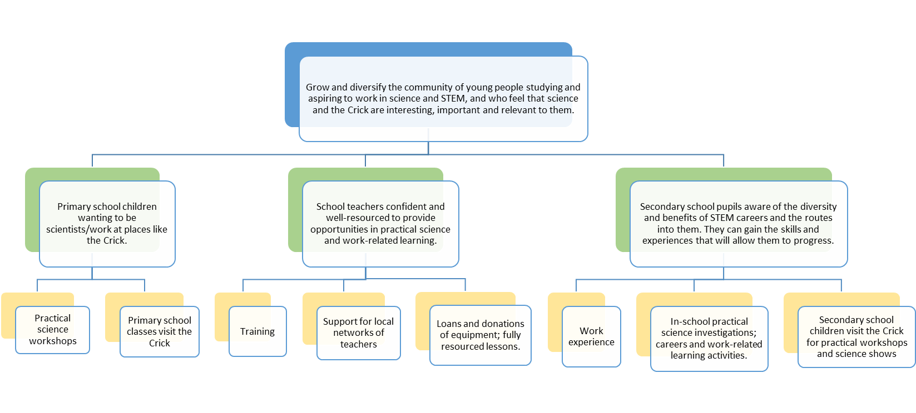

Goal (top row)

Outcomes (middle row)

Activities (bottom row)