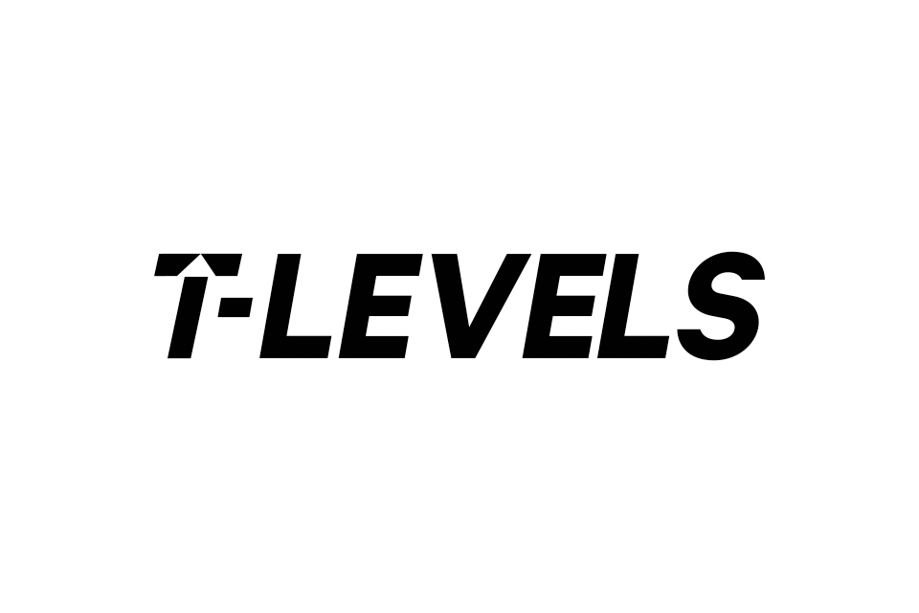

**Civil Service Industry Placements Student Travel and Subsistence Policy**

Travel should be booked in line with the Student Expenses Policy documented below.

Your college will provide you with travel expenses from the place where you normally live or study to where you are undertaking your placement. Your journey should be by the most economical method of travel.

**Please retain all original receipts and submit them to your college representative.** Your college will advise you as to how frequently you need to submit your receipts.

**Student Travel Expenses Policy**

1. Rail

We can only reimburse standard class fare, however, please take advantage of any available cheap or discounted fares by booking ahead where possible. Please avoid booking open train tickets as these are the most expensive. Only the cheapest ticket available will be reimbursed and if a more expensive ticket is purchased (i.e. a flexible or open ticket) the cost cannot be claimed. We will also reimburse for local tube, metro and bus journeys. Taxi travel (unless previously agreed with the Civil Service Industry Placements team) will not be permitted.

2. Private Car

If it is more cost effective to travel by private car you will be refunded at the rate of 26p per mile. You cannot claim mileage if you are a passenger in another student’s car. However, you can claim 2p per mile for a passenger. Please note: Taxi fares and car parking fees are not reimbursed. Any charges or fines incurred will not be reimbursed.

3. Motorcycle

You will be refunded at a rate of 24p per mile.

4.Students travelling from Abroad

You may claim travelling expenses, as above, only between the place of arrival in the United Kingdom and the base office. We cannot reimburse the cost of entry into the UK.

5. Air Travel

Air fares will only be refunded where they are cheaper than the cost of travelling a surface route; including overnight expenses where necessary.

6. Students requiring a Personal Assistant or assistance with mobility.

If you have a disability and you need a personal assistant or supporter to assist you whilst undertaking your placement or if you will experience difficulty with travelling arrangements please consult the CSIP Team at csindustryplacement@cabinetoffice.gov.uk.

**Student Subsistence Expenses Policy**

Subsistence in this instance is defined as costs relating to meals. Subsistence costs you actually and necessarily incur will be covered under this policy.

You are entitled to claim £5 a day towards lunch. Any beverages claimed for as subsistence must be non-alcoholic.

**Rates for subsistence are benchmark ceiling rates that you should always seek to meet or spend less than.**

**Queries**

If you have any queries please contact [csindustryplacement@cabinetoffice.gov.uk](mailto:csindustryplacement@cabinetoffice.gov.uk).

**Misuse of funds towards travel and subsistence could result in termination of your placement.**