|  |
| --- |
| ***WHICH***  ***T LEVELS COULD BE RELEVANT TO US?*** |

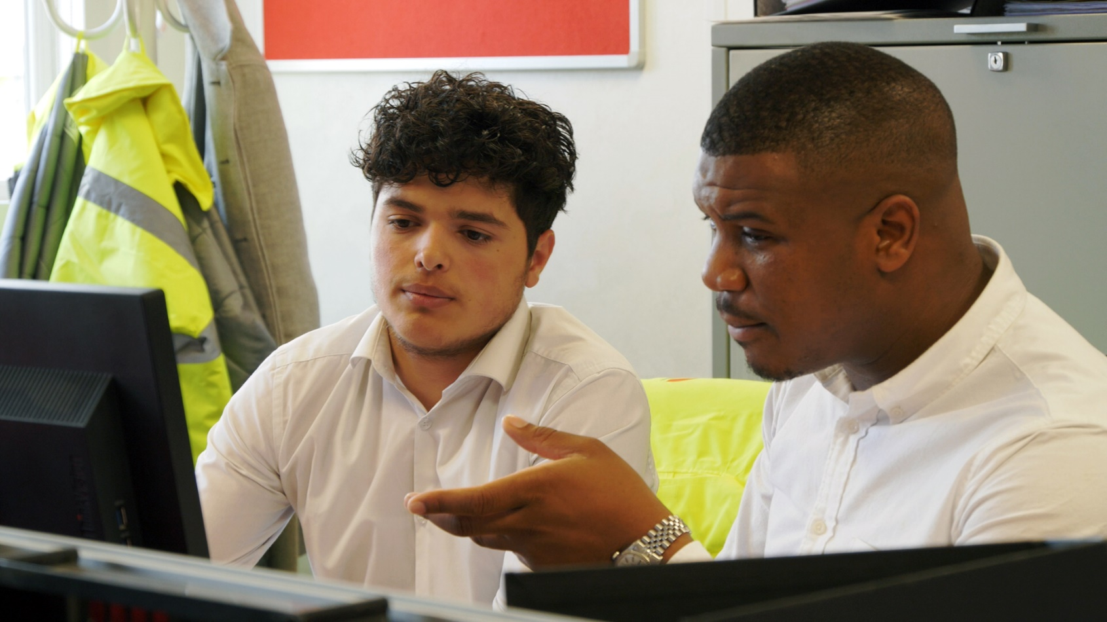

Over the next few years, T Levels will scale to include more than 20 courses, covering 11 skill areas. Each skill area contains several occupational specialisms.

|  |  |  |
| --- | --- | --- |
| ***AGRICULTURE, ENVIRONMENTAL AND ANIMAL CARE***   * animal care and management * agriculture, land management and production | ***BUSINESS AND ADMINISTRATION***   * management and administration | ***CATERING AND HOSPITALITY***   * Catering |
| ***CONSTRUCTION***   * design, surveying and planning * onsite construction * building services engineering | ***CREATIVE AND DESIGN***   * craft and design * media, broadcast and production | ***DIGITAL AND IT***   * digital support services * digital production, design and development * digital business services |
| ***EDUCATION AND CHILDCARE***   * early years education and childcare * assisting teaching | ***ENGINEERING AND MANUFACTURING***   * design and development * maintenance, installation and repair * manufacturing, processing and control | ***HAIR AND BEAUTY***   * hairdressing, barbering and beauty therapy |
| ***HEALTH AND SCIENCE***   * health * healthcare science * science | ***LEGAL, FINANCE AND ACCOUNTING***   * legal * finance * accounting | ***SALES, MARKETING AND PROCUREMENT***   * marketing |

Decide which skill area you could be interested as these they do not need to be the primary focus of your business. It may be that you could offer placements in several skill areas. These could also include more widely-applicable skill areas like digital, business and administration, or legal, finance and accounting.

Then go to the page which lists the occupations in each skill area. Use the tables to decide:

* which could be relevant to you
* which roles in the organisation they link to
* whether you could potentially offer a placement in any of these occupations

***Agriculture, Environment and Animal Care***

| ***T LEVEL*** | ***OCCUPATIONAL SPECIALISM*** | ***RELEVANT TO US?*** | ***ROLES IN OUR ORGANISATION THIS COULD LINK TO*** | ***COULD WE OFFER A PLACEMENT?*** |
| --- | --- | --- | --- | --- |
| **Agriculture, Land Management and Production** | Crop Production |  |  |  |
| Floristry |  |  |  |
| Land-based Engineering |  |  |  |
| Livestock Production |  |  |  |
| Tree and Woodland Management and Maintenance |  |  |  |
| **Animal Care and Management** | Animal Management and Behaviour |  |  |  |
| Animal Management and Science |  |  |  |

***Business and Administration***

| ***T LEVEL*** | ***OCCUPATIONAL SPECIALISM*** | ***RELEVANT TO US?*** | ***ROLES IN OUR ORGANISATION THIS COULD LINK TO*** | ***COULD WE OFFER A PLACEMENT?*** |
| --- | --- | --- | --- | --- |
| **Management and Administration** | Business Improvement |  |  |  |
| Team Leadership/Management |  |  |  |
| Business Support |  |  |  |
| Information Management |  |  |  |

***Catering***

| ***T LEVEL*** | ***OCCUPATIONAL SPECIALISM*** | ***RELEVANT TO US?*** | ***ROLES IN OUR ORGANISATION THIS COULD LINK TO*** | ***COULD WE OFFER A PLACEMENT?*** |
| --- | --- | --- | --- | --- |
| **Catering** | Not yet confirmed |  |  |  |

***Construction***

| ***T LEVEL*** | ***OCCUPATIONAL SPECIALISM*** | ***RELEVANT TO US?*** | ***ROLES IN OUR ORGANISATION THIS COULD LINK TO*** | ***COULD WE OFFER A PLACEMENT?*** |
| --- | --- | --- | --- | --- |
| **Design, Surveying and Planning for Construction** | Building Services Design |  |  |  |
| Civil Engineering |  |  |  |
| Hazardous Materials Analysis and Surveying |  |  |  |
| Surveying and Design for Construction and the Built Environment |  |  |  |
| **On-site Construction** | Bricklaying |  |  |  |
| Carpentry and Joinery |  |  |  |
| Painting and Decorating |  |  |  |
| Plastering |  |  |  |
| **Building Services Engineering for Construction** | Air Conditioning Engineering |  |  |  |
| Electrical and Electronic Equipment Engineering |  |  |  |
| Gas Engineering |  |  |  |
| Heating Engineering |  |  |  |
| Plumbing |  |  |  |
| Protection Systems Engineering |  |  |  |
| Refrigeration Engineering |  |  |  |
| Ventilation |  |  |  |

***Creative and Design***

| ***T LEVEL*** | ***OCCUPATIONAL SPECIALISM*** | ***RELEVANT TO US?*** | ***ROLES IN OUR ORGANISATION THIS COULD LINK TO*** | ***COULD WE OFFER A PLACEMENT?*** |
| --- | --- | --- | --- | --- |
| **Craft and Design** | Jewellery Maker |  |  |  |
| Ceramics Maker |  |  |  |
| Furniture Maker |  |  |  |
| Textiles and Fashion Maker |  |  |  |
| **Media, Broadcast and Production** | Content Creation and Production |  |  |  |
| Creative Media Technician |  |  |  |
| Events and Venues Technician |  |  |  |

***Digital / IT***

| ***T LEVEL*** | ***OCCUPATIONAL SPECIALISM*** | ***RELEVANT TO US?*** | ***ROLES IN OUR ORGANISATION THIS COULD LINK TO*** | ***COULD WE OFFER A PLACEMENT?*** |
| --- | --- | --- | --- | --- |
| **Digital Production, Design and Development** | Digital Production, Design and Development |  |  |  |
| **Digital Support Services** | Digital Infrastructure |  |  |  |
| Network Cabling |  |  |  |
| Digital Support |  |  |  |
| **Digital Business Services** | Data Technician |  |  |  |

***Education & Childcare***

| ***T LEVEL*** | ***OCCUPATIONAL SPECIALISM*** | ***RELEVANT TO US?*** | ***ROLES IN OUR ORGANISATION THIS COULD LINK TO*** | ***COULD WE OFFER A PLACEMENT?*** |
| --- | --- | --- | --- | --- |
| **Education and Childcare** | Early Years Education and Childcare |  |  |  |
| Assisting Teaching |  |  |  |

***Engineering and Manufacturing***

| ***T LEVEL*** | ***OCCUPATIONAL SPECIALISM*** | ***RELEVANT TO US?*** | ***ROLES IN OUR ORGANISATION THIS COULD LINK TO*** | ***COULD WE OFFER A PLACEMENT?*** |
| --- | --- | --- | --- | --- |
| **Design and Development** | Mechanical Engineering |  |  |  |
| Electrical and Electronic Engineering |  |  |  |
| Control and Instrumentation Engineering |  |  |  |
| Structural Engineering |  |  |  |
| **Maintenance, Installation and Repair** | Mechanical |  |  |  |
| Mechatronic |  |  |  |
| Electrical and Electronic |  |  |  |
| Control and Instrumentation |  |  |  |
| Vehicles |  |  |  |
| Energy and Utilities |  |  |  |
| **Manufacturing, Processing and Control** | Manufacturing Technologies |  |  |  |
| Production Technologies |  |  |  |
| Processing Technologies |  |  |  |
| Materials Technologies |  |  |  |

***Hair and Beauty***

| ***T LEVEL*** |  | ***RELEVANT TO US?*** | ***ROLES IN OUR ORGANISATION THIS COULD LINK TO*** | ***COULD WE OFFER A PLACEMENT?*** |
| --- | --- | --- | --- | --- |
| **Hairdressing, barbering and beauty therapy** | Barbering |  |  |  |
| Hairdressing |  |  |  |
| Beauty Therapy |  |  |  |

***Health and Science***

| ***T LEVEL*** | ***OCCUPATIONAL SPECIALISM*** | ***RELEVANT TO US?*** | ***ROLES IN OUR ORGANISATION THIS COULD LINK TO*** | ***COULD WE OFFER A PLACEMENT?*** |
| --- | --- | --- | --- | --- |
| **Health** | Dental Nursing |  |  |  |
| Supporting Healthcare |  |  |  |
| **Healthcare Science** | Optical Care Services |  |  |  |
| Pharmacy Services |  |  |  |
| Assisting with Healthcare Science |  |  |  |
| Dental Technical Services |  |  |  |
| Prosthetic and Orthotic Technical Services |  |  |  |
| **Science** | Laboratory Sciences |  |  |  |
| Food Sciences |  |  |  |
| Animal Sciences |  |  |  |
| Metrology Sciences |  |  |  |

***Legal, Finance and Accounting***

| ***T LEVEL*** | ***OCCUPATIONAL SPECIALISM*** | ***RELEVANT TO US?*** | ***ROLES IN OUR ORGANISATION THIS COULD LINK TO*** | ***COULD WE OFFER A PLACEMENT?*** |
| --- | --- | --- | --- | --- |
| **Finance** | Retail and Commercial Banking Analyst |  |  |  |
| Investment Banking and Asset and Wealth Management Analyst |  |  |  |
| Insurance Practitioner |  |  |  |
| Financial Compliance/Risk Analyst |  |  |  |
| Financial Operations Analyst |  |  |  |
| **Legal** | Legal Services Assistant Business, Finance and Employment |  |  |  |
| Legal Services Assistant Dispute Resolution |  |  |  |
| Legal Services Assistant Private Client |  |  |  |
| Legal Services Assistant Crime and the Criminal Justice System |  |  |  |
| Legal Services Assistant Social Welfare and Immigration |  |  |  |
| **Accounting** | Assistant Accountant |  |  |  |

***Sales, Marketing and Procurement***

| ***T LEVEL*** | ***OCCUPATIONAL SPECIALISM*** | ***RELEVANT TO US?*** | ***ROLES IN OUR ORGANISATION THIS COULD LINK TO*** | ***COULD WE OFFER A PLACEMENT?*** |
| --- | --- | --- | --- | --- |
| **Marketing** | Not yet confirmed |  |  |  |