List of words used to describe activities during T Level industry placements
The graphic and list below contains words used by employers in the video to describe activities that make industry placements meaningful and interesting to students. Use it to:
- Plan a varied and stimulating range of work for students to do during their placement
- Explain to students what they are doing, e.g. ‘shadowing’ means following experienced members of staff and observing them carefully as they do their job
- Think of other activities that make the experience of being on a placement in your organisation beneficial to students.
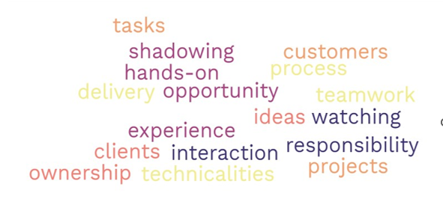

Meaningful and interesting activities | How to explain or demonstrate to the student
Tasks
Shadowing
Customers
Hands-on
Delivery
Opportunity
Teamwork
Experience
Ideas
Clients
Watching
Interaction
Responsibility
Projects
Technicalities
Ownership

